Dis-Asia-Indus-Seal-Harappa-300-2500 BCE-Collection

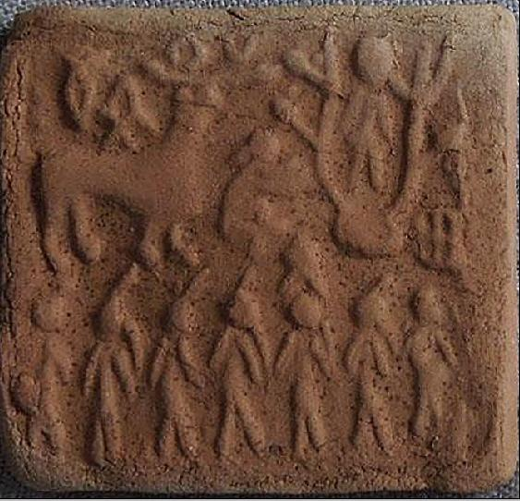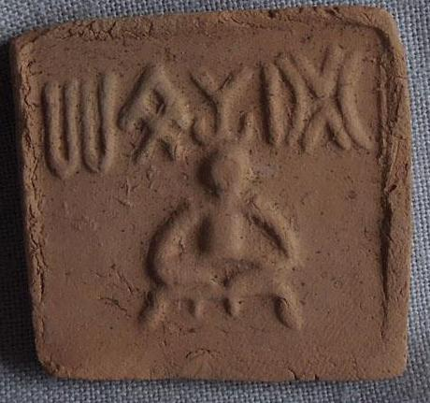

1. Ceremony 2. Proto Shiva

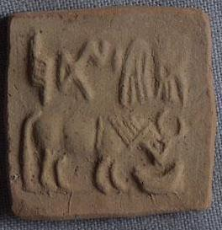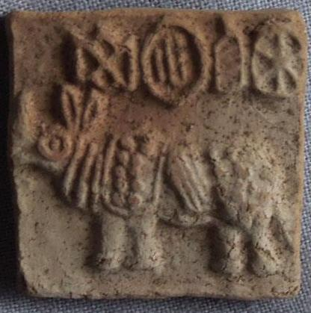

3. Bull 4. Animal

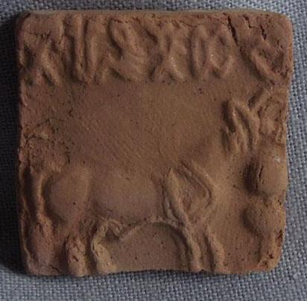

1. Animal

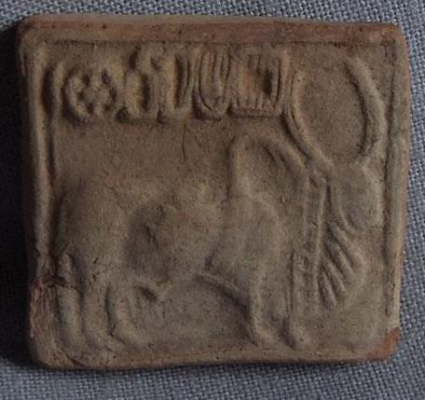

6. Sacred Brahman Bull

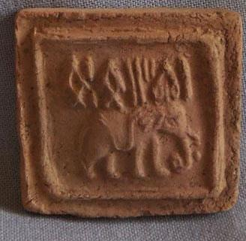

7. Elephant

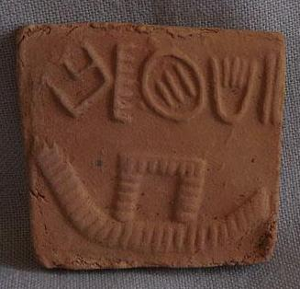

8. Maritime Vessel

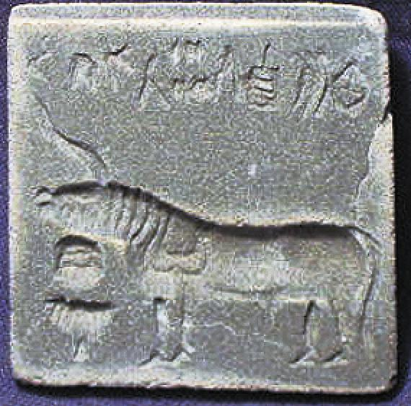

9. Unicorn, ritual offering stand, 8 symbols above. 4cm. x 4cm.

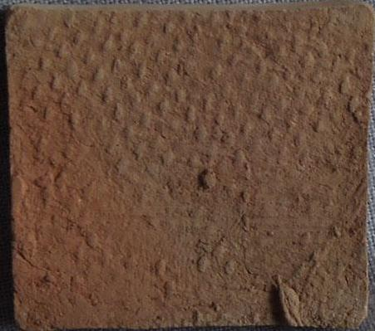

1.

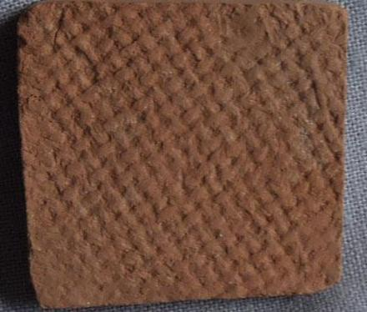

2.

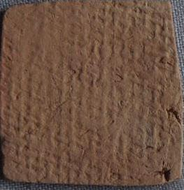

3.

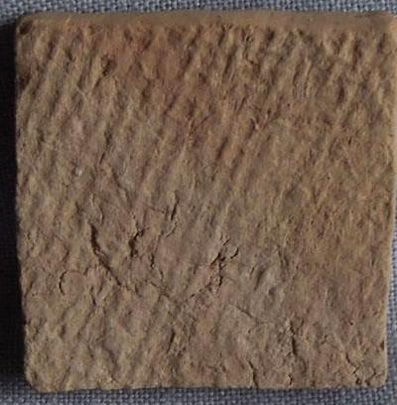

4.

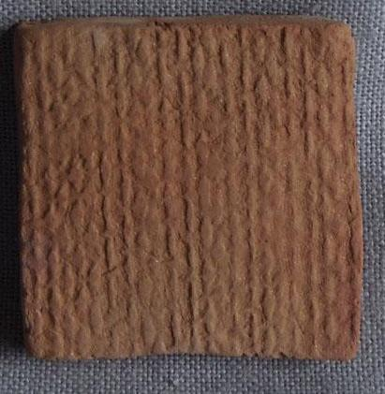

5.

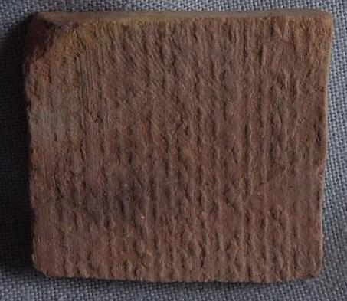

6. Stuctured surface

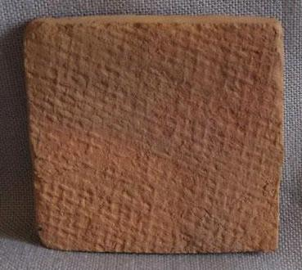

7.

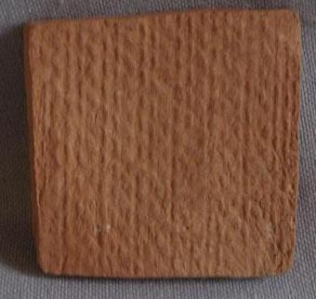

8.

Sold by [tribal*focus](http://myworld.ebay.com/tribal*focus) ( [6609](http://feedback.ebay.com/ws/eBayISAPI.dll?ViewFeedback&userid=tribal*focus) )

### Delivery package 1 of 1

Estimated delivery Wednesday, May 4, 2016 - Thursday, May 12, 2016

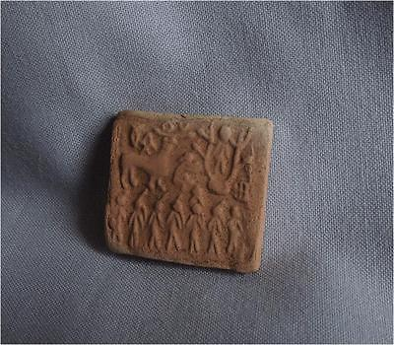

#### [Antique Pakistan TOP HIGH AGED INDUS HARAPPA CLAY SEALING TABLET WITH CEREMONY](http://www.ebay.com/itm/301931583913)

|  |  |
| --- | --- |
| Item price | $59.90 |
| Quantity | 1 |
| Item number | 301931583913 |
| Shipping service | Standard Shipping |

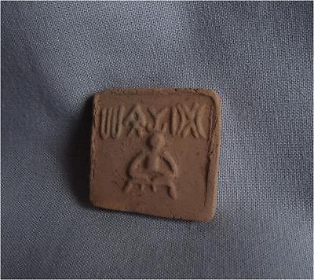

#### [Antique Pakistan TOP HIGH AGED INDUS HARAPPA CLAY SEALING TABLET WITH PROTOSHIVA](http://www.ebay.com/itm/301931584682)

|  |  |
| --- | --- |
| Item price | $64.99 |
| Quantity | 1 |
| Item number | 301931584682 |
| Shipping service | Standard Shipping |

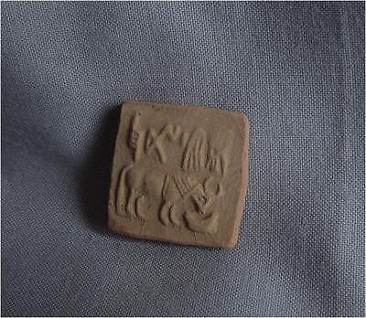

#### [Antique Pakistan TOP HIGH AGED INDUS HARAPPA CLAY SEALING TABLET WITH ANIMAL](http://www.ebay.com/itm/301931585165)

|  |  |
| --- | --- |
| Item price | $59.90 |
| Quantity | 1 |
| Item number | 301931585165 |
| Shipping service | Standard Shipping |

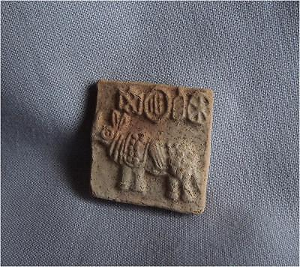

#### [Antique Pakistan TOP HIGH AGED INDUS HARAPPA CLAY SEALING TABLET WITH ANIMAL](http://www.ebay.com/itm/291739618198)

|  |  |
| --- | --- |
| Item price | $61.00 |
| Quantity | 1 |
| Item number | 291739618198 |
| Shipping service | Standard Shipping |

## Shipping address

Ralph J Coffman Jr

149 Atlantic Ave

Swampscott MA 01907-2427

United States

## Order total

|  |  |
| --- | --- |
| Subtotal | $245.79 |
| Shipping | $20.00 |

**Total**

$265.79

Order placed on

Saturday, Apr 23, 2016

Payment method

Credit card

Payment date

Saturday, Apr 23, 2016

### Delivery package 1 of 1

Estimated delivery Friday, Jun 3, 2016 -Friday, Jun 10, 2016

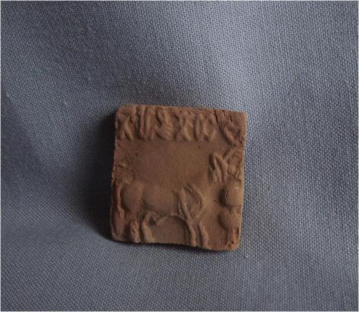

#### [Antique Pakistan TOP HIGH AGED INDUS HARAPPA CLAY SEALING TABLET WITH ANIMAL](http://www.ebay.com/itm/291764146046)

|  |  |
| --- | --- |
| **Item price** | $59.90 |
| **Quantity** | 1 |
| **Item number** | 291764146046 |
| **Shipping service** | Standard Shipping |

[Contact seller](http://contact.ebay.com/ws/eBayISAPI.dll?FindAnswers&frm=3998&iid=291764146046&redirect=0&requested=tribal*focus)

[Return item](https://www.ebay.com/rtn/Return/ReturnViewSelectedItem?transactionId=0&itemId=291764146046&_trksid=p2057872.m2749.l3185)

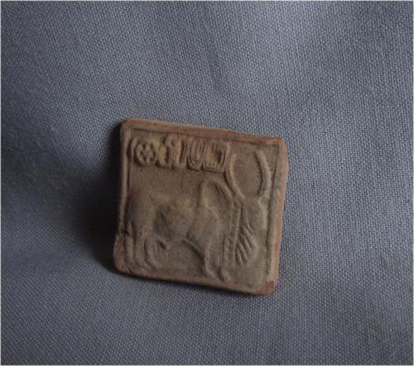

#### [Antique Pakistan TOP HIGH AGED INDUS HARAPPA CLAY SEALING TABLET WITH ANIMAL](http://www.ebay.com/itm/291764146385)

|  |  |
| --- | --- |
| **Item price** | $59.90 |
| **Quantity** | 1 |
| **Item number** | 291764146385 |
| **Shipping service** | Standard Shipping |

[Contact seller](http://contact.ebay.com/ws/eBayISAPI.dll?FindAnswers&frm=3998&iid=291764146385&redirect=0&requested=tribal*focus)

[Return item](https://www.ebay.com/rtn/Return/ReturnViewSelectedItem?transactionId=0&itemId=291764146385&_trksid=p2057872.m2749.l3185)

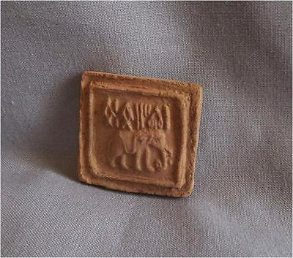

#### [Antique Pakistan TOP HIGH AGED INDUS HARAPPA CLAY SEALING TABLET WITH ANIMAL](http://www.ebay.com/itm/291764146791)

|  |  |
| --- | --- |
| **Item price** | $84.00 |
| **Quantity** | 1 |
| **Item number** | 291764146791 |
| **Shipping service** | Standard Shipping |

[Contact seller](http://contact.ebay.com/ws/eBayISAPI.dll?FindAnswers&frm=3998&iid=291764146791&redirect=0&requested=tribal*focus)

[Return item](https://www.ebay.com/rtn/Return/ReturnViewSelectedItem?transactionId=0&itemId=291764146791&_trksid=p2057872.m2749.l3185)

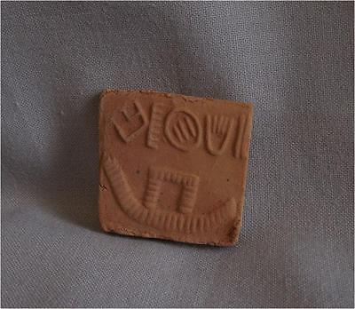

#### [Antique Pakistan TOP HIGH AGED INDUS HARAPPA CLAY SEALING TABLET WITH BOAT](http://www.ebay.com/itm/291764147397)

|  |  |
| --- | --- |
| **Item price** | $59.90 |
| **Quantity** | 1 |
| **Item number** | 291764147397 |
| **Shipping service** | Standard Shipping |

# Order details

Printer friendly page

## Sales order

Sold by [tribal*focus](http://myworld.ebay.com/tribal*focus) ( [6662](http://feedback.ebay.com/ws/eBayISAPI.dll?ViewFeedback&userid=tribal*focus) )

+ Show additional actions

### Delivery package 1 of 1

Delivered on Wednesday, May 4, 2016

+ Show shipping details

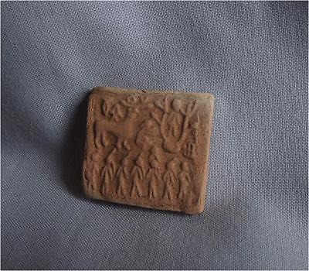

#### [Antique Pakistan TOP HIGH AGED INDUS HARAPPA CLAY SEALING TABLET WITH CEREMONY](http://www.ebay.com/itm/301931583913)

|  |  |
| --- | --- |
| **Item price** | $59.90 |
| **Quantity** | 1 |
| **Item number** | 301931583913 |
| **Shipping service** | Standard Shipping |

[Leave feedback](http://feedback.ebay.com/ws/eBayISAPI.dll?LeaveFeedbackShow&useridfrom=802-867&useridto=tribal*focus&item=301931583913&transactid=0)

[Contact seller](http://contact.ebay.com/ws/eBayISAPI.dll?FindAnswers&frm=3998&iid=301931583913&redirect=0&requested=tribal*focus)

[Return item](https://www.ebay.com/rtn/Return/ReturnViewSelectedItem?transactionId=0&itemId=301931583913&_trksid=p2057872.m2749.l3185)

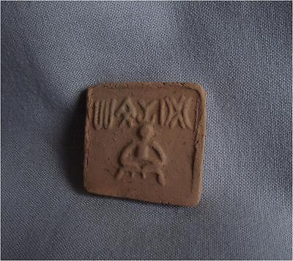

#### [Antique Pakistan TOP HIGH AGED INDUS HARAPPA CLAY SEALING TABLET WITH PROTOSHIVA](http://www.ebay.com/itm/301931584682)

|  |  |
| --- | --- |
| **Item price** | $64.99 |
| **Quantity** | 1 |
| **Item number** | 301931584682 |
| **Shipping service** | Standard Shipping |

[Leave feedback](http://feedback.ebay.com/ws/eBayISAPI.dll?LeaveFeedbackShow&useridfrom=802-867&useridto=tribal*focus&item=301931584682&transactid=0)

[Contact seller](http://contact.ebay.com/ws/eBayISAPI.dll?FindAnswers&frm=3998&iid=301931584682&redirect=0&requested=tribal*focus)

[Return item](https://www.ebay.com/rtn/Return/ReturnViewSelectedItem?transactionId=0&itemId=301931584682&_trksid=p2057872.m2749.l3185)

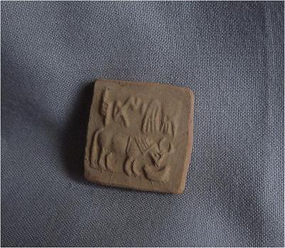

#### [Antique Pakistan TOP HIGH AGED INDUS HARAPPA CLAY SEALING TABLET WITH ANIMAL](http://www.ebay.com/itm/301931585165)

|  |  |
| --- | --- |
| **Item price** | $59.90 |
| **Quantity** | 1 |
| **Item number** | 301931585165 |
| **Shipping service** | Standard Shipping |

[Leave feedback](http://feedback.ebay.com/ws/eBayISAPI.dll?LeaveFeedbackShow&useridfrom=802-867&useridto=tribal*focus&item=301931585165&transactid=0)

[Contact seller](http://contact.ebay.com/ws/eBayISAPI.dll?FindAnswers&frm=3998&iid=301931585165&redirect=0&requested=tribal*focus)

[Return item](https://www.ebay.com/rtn/Return/ReturnViewSelectedItem?transactionId=0&itemId=301931585165&_trksid=p2057872.m2749.l3185)

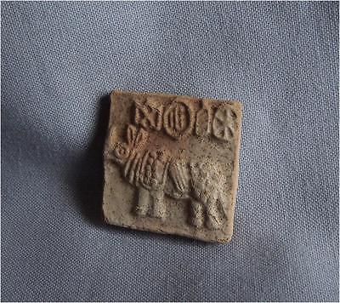

#### [Antique Pakistan TOP HIGH AGED INDUS HARAPPA CLAY SEALING TABLET WITH ANIMAL](http://www.ebay.com/itm/291739618198)

|  |  |
| --- | --- |
| **Item price** | $61.00 |
| **Quantity** | 1 |
| **Item number** | 291739618198 |
| **Shipping service** | Standard Shipping |

[Leave feedback](http://feedback.ebay.com/ws/eBayISAPI.dll?LeaveFeedbackShow&useridfrom=802-867&useridto=tribal*focus&item=291739618198&transactid=0)

[Contact seller](http://contact.ebay.com/ws/eBayISAPI.dll?FindAnswers&frm=3998&iid=291739618198&redirect=0&requested=tribal*focus)

[Return item](https://www.ebay.com/rtn/Return/ReturnViewSelectedItem?transactionId=0&itemId=291739618198&_trksid=p2057872.m2749.l3185)

## Shipping address

Ralph J Coffman Jr

149 Atlantic Ave

Swampscott MA 01907-2427

United States

## Order total

|  |  |
| --- | --- |
| **Subtotal** | $245.79 |
| **Shipping** | $20.00 |

**Total**

$265.79